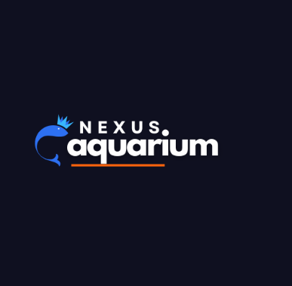

NEXUS AQUARIUM

DOCUMENTATION



**By: Sania Khan**

**static website**

**Web Technologies: HTML , CSS , JQUERY, VANILLA JAVASCRIPT**

Navbar (sticky):

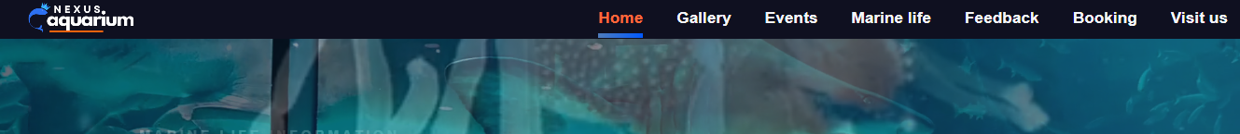

NAVBAR STICKY SOLID BACKGROUND

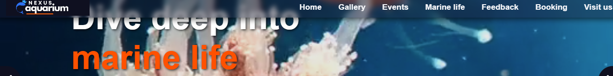

NAVBAR TRANSPARENT WHILE SCROLLED

At the top our Navbar has links that are linked with anchors across the sections within our website. The header has been made sticky that help user to navigate to any section they wanted without scrolling back to top.

A further enhancement has been made with a custom function using vanilla javascript that turns the header transparent when the user starts scrolling down.

Hero section:

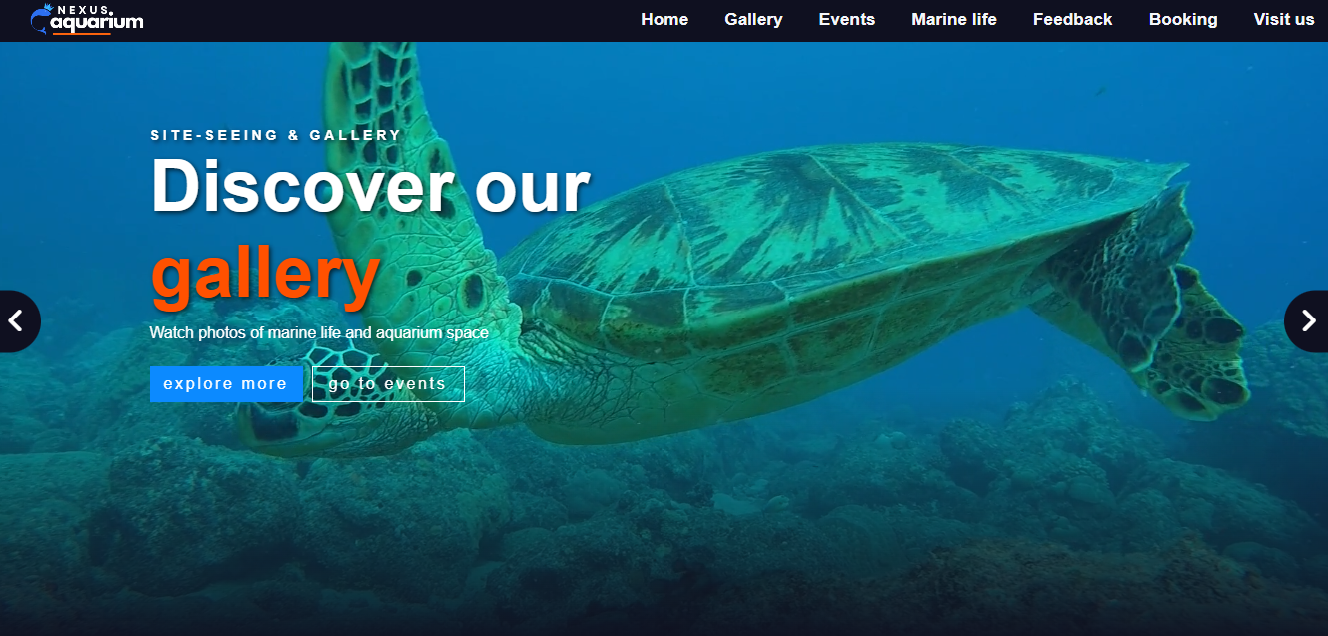

In this section we’ve created a carousel that displays 4 slides each of which has a button for events and other to explore that particular section. It would help user to navigate through different sections of our website and find what they are looking for.

Site exploration:

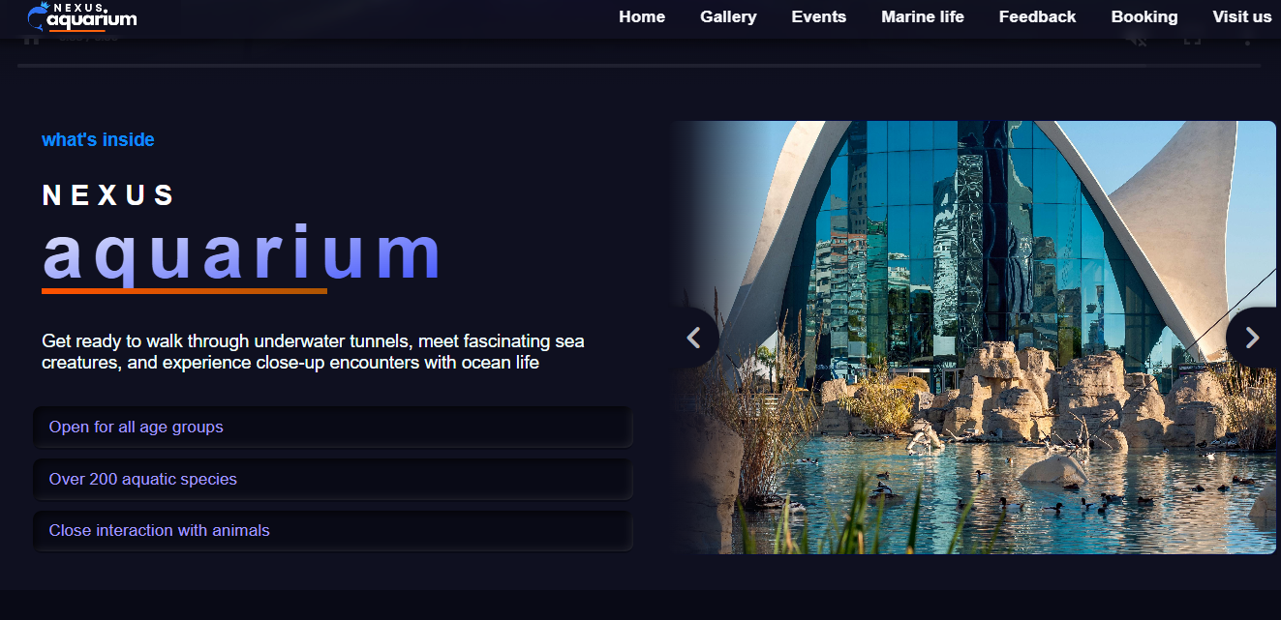

Moving to the next section, this will further help them explore the site architecture and surroundings. Creating a warm and friendly experience beforehand they visit our home spot. Aesthetics have been added with linear gradient and box shadow effect to display the perks we offer to our customers.

Aquarium Gallery:

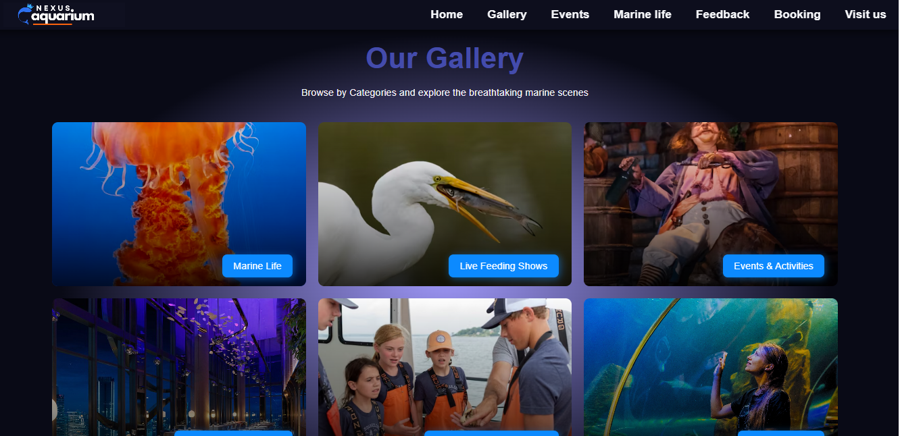

FLIP CARDS FRONT

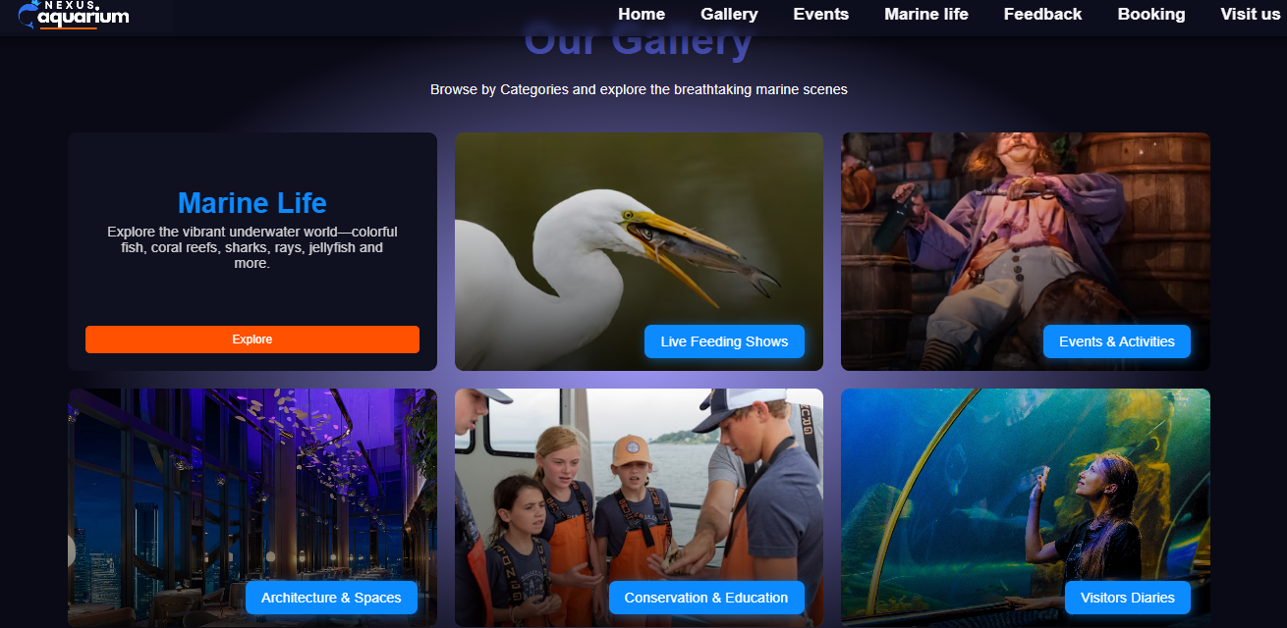

FLIP CARDS BACK

Through this section our visitors can explore images within each of their favorite categories knowing the inside out of our place,that would help them to make a decision to land plan their first visit. Here the aesthetic part is our flip cards that flips and show details on hover, meanwhile the front side also show up a title besides showing details on hover.

Site-seeing places (supporting section):

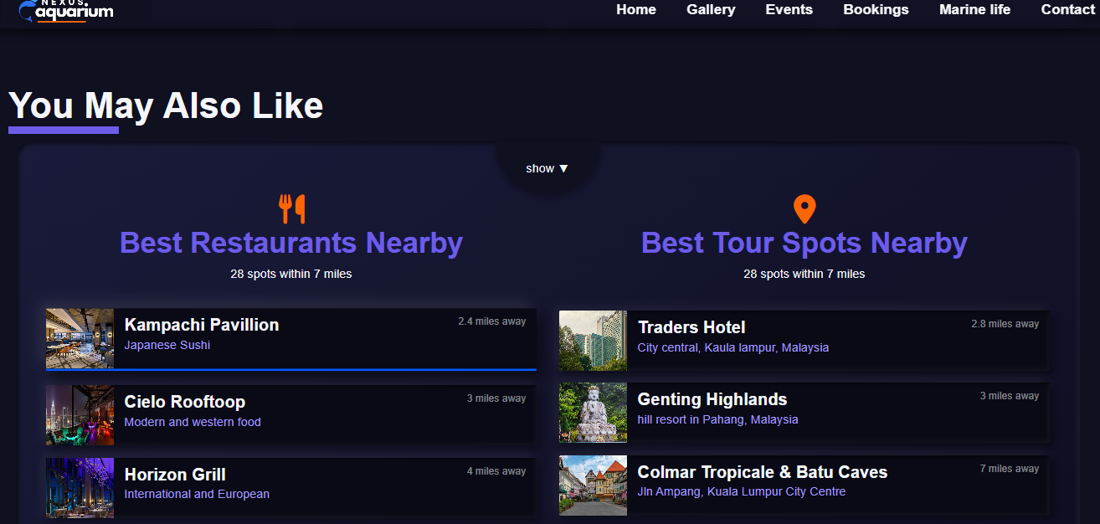

This section is a supporting section that is recommended within project requirements. It is a great way to catch visitor attention that your location has some great nearby sites to visit to than just the place itself.

It has been made functional if user only intereted to see it on the click of a down arrow icon otherwise they could scroll down through the website.

Upcoming Events:

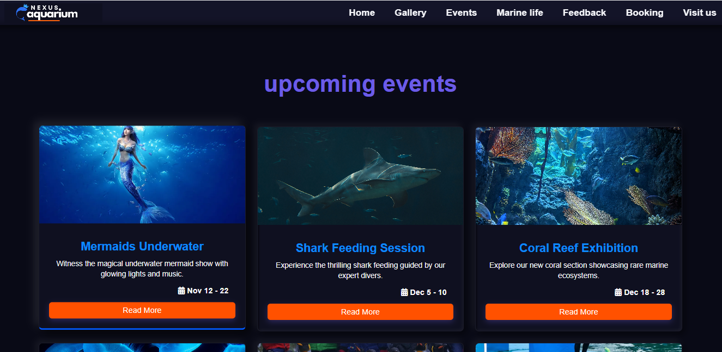

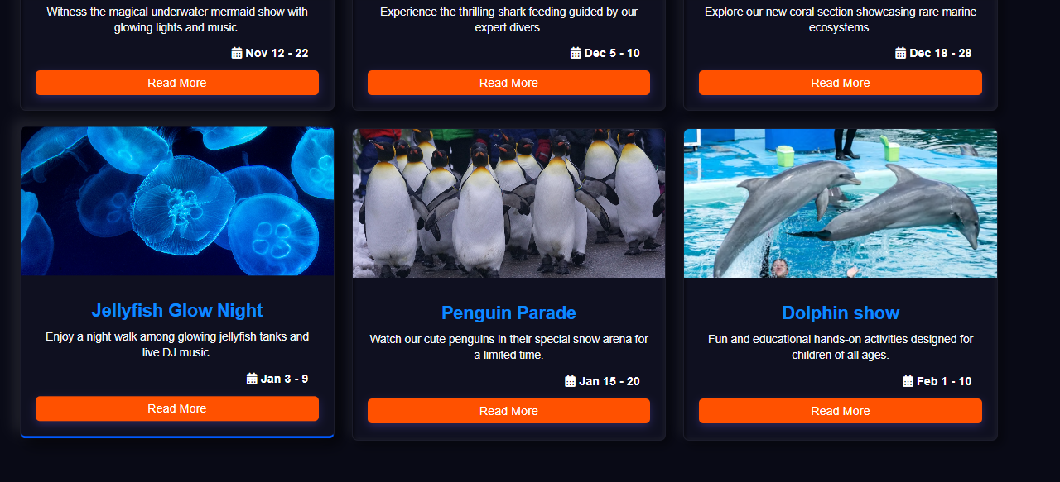

Our website has separate event cards that are especially for children, equally enjoyable by adults. On the click of the button they will be landing on our (dummy page) booking form.

Marine Life Information (table):

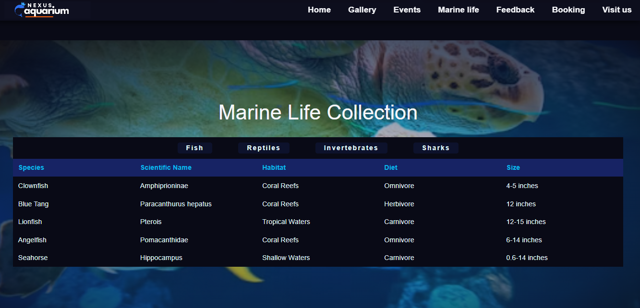

Every visitor might be looking for the species and marine animals they’re going to visit through our aquarium. This tables meant to cover species that we’ve kept inside.

The topmost bar holds all the main categories on the click of the specific category a data (table) appears that has been added using J-query. For the background, a radial-gradient with theme colors has been set on the background-image url.

Visit-Us section with google map embedded:

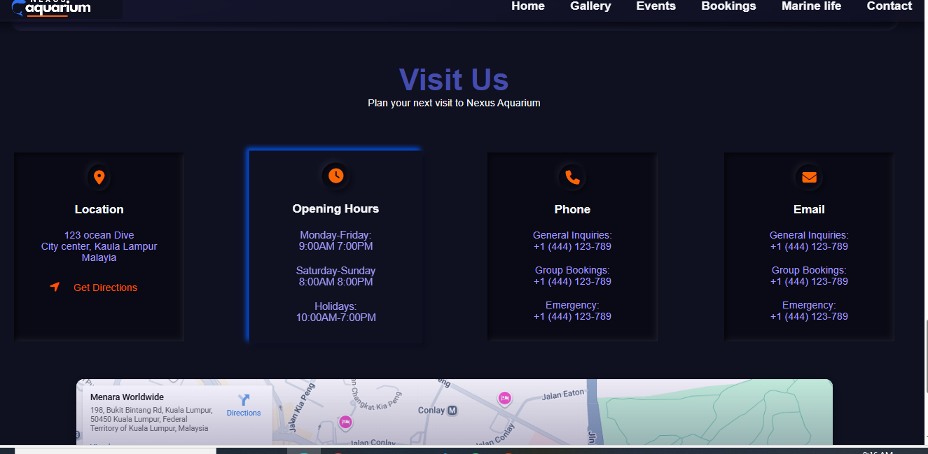

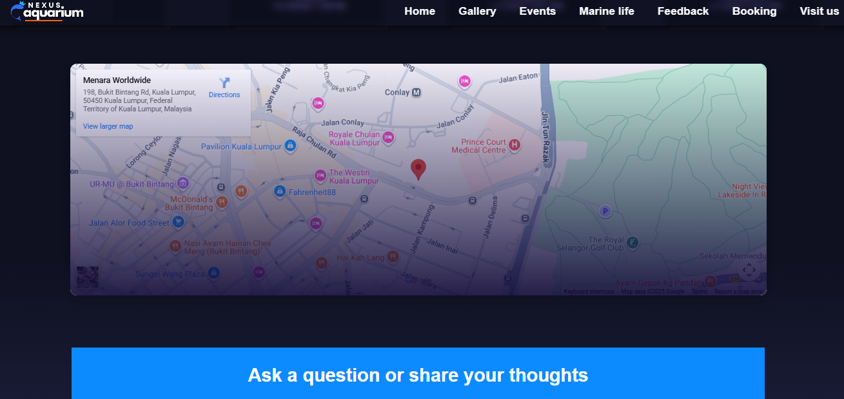

At the very bottom above footer a visit us section showcase important notes within cards regarding opening timing, site location and contact details.

Also, a google map has been embedded that further supports the section and can help the user to pin the location. Over the container a gradient overlay has been added that turns transparent on hover to display a clear visual of the map.

Feedback form & Booking form/Contact us (dummy page):

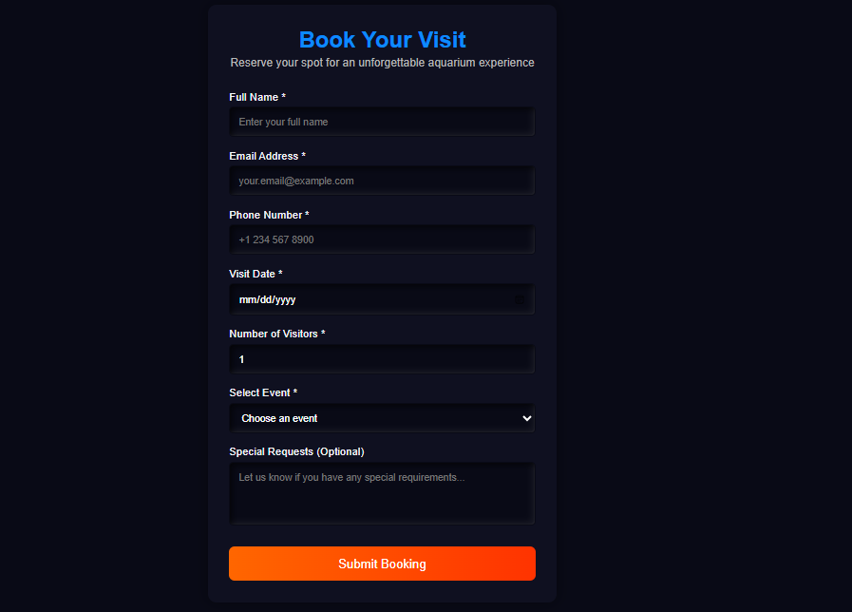 BOOKING FORM

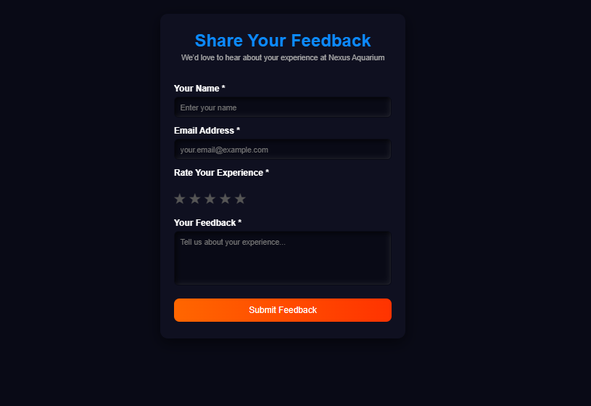 FEEDBACK FORM

These forms had been purposefully built to help complete user their desired actions either booking an event or share their insights. The form validation has been done using Javascript which shows a ‘success’ message in alert when all the required fields have been filled.

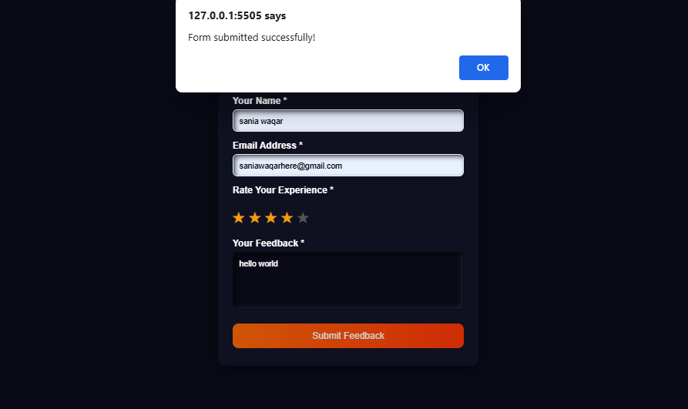

Footer:

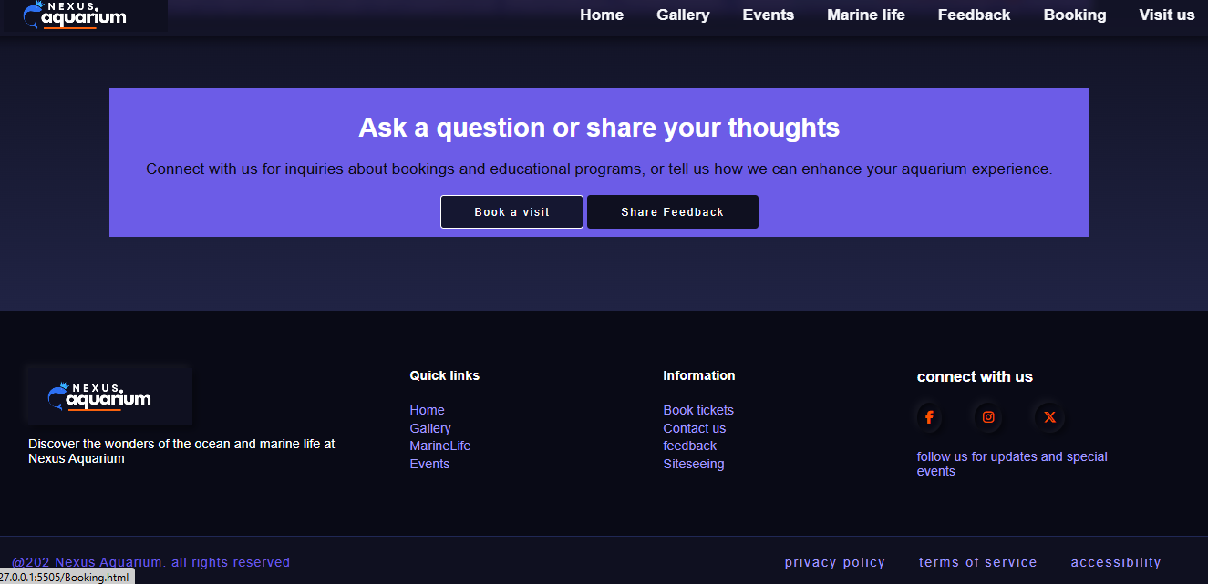

Heading towards the last section the two buttons with anchors will lead user to book a visit or share a feedback which is a crucial standpoint before the user leaves the site.

In the end we’ve footer that has quick links, information and other social-links to let them stay updated and navigate all across website in case they missed any information they needed.